Registration Guide for non-Austrian
companies that carry out waste transports
in Austria
edm.gv.at
In order to register as a company (legal person / organisation) that carries out waste
transportations in Austria, you must visit the website edm.gv.at and complete an online
registration form (Registration Request). This guide is intended to help you to fill in the
registration form.
Please choose the English language. The registration form is on the right hand side of the
website (Registration Request):
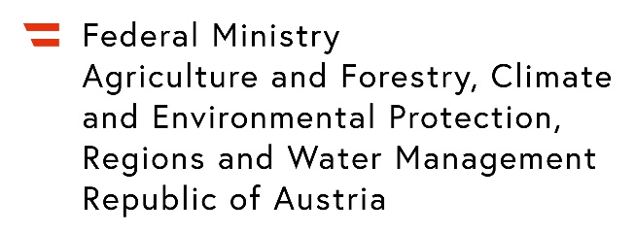
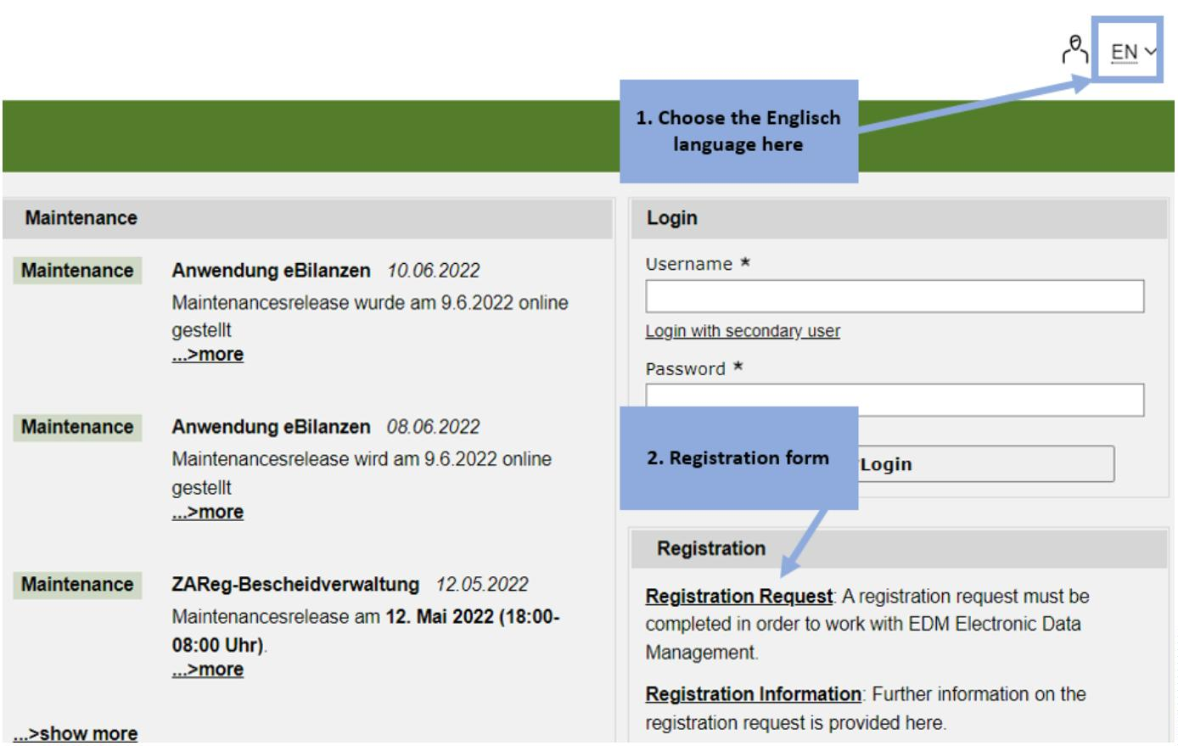

As a company please choose the entry “legal person/organisation”.
Please omit the first four entry fields if you do not have an Austrian ID. Please type in the
name of the company and choose the legal form of the company. For companies outside
Austria, choose “Non-Austrian legal form”.
Please select the state and type in the address of the company. The state must be chosen
from the drop-down-menu. Please make sure that you provide the e-mail address.
Registration Guide for non-Austrian companies that carry out waste transports in Austria
Page 2 of 5
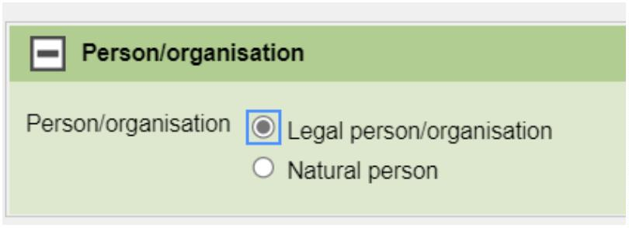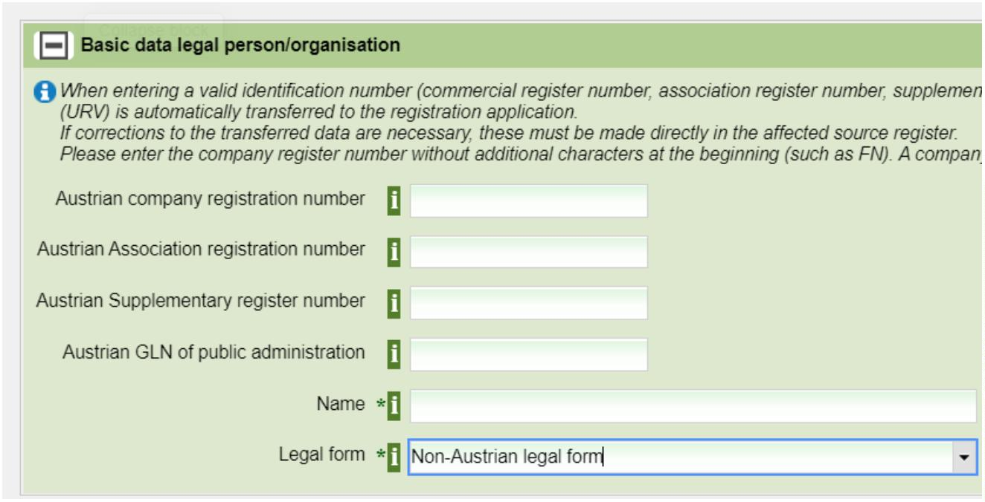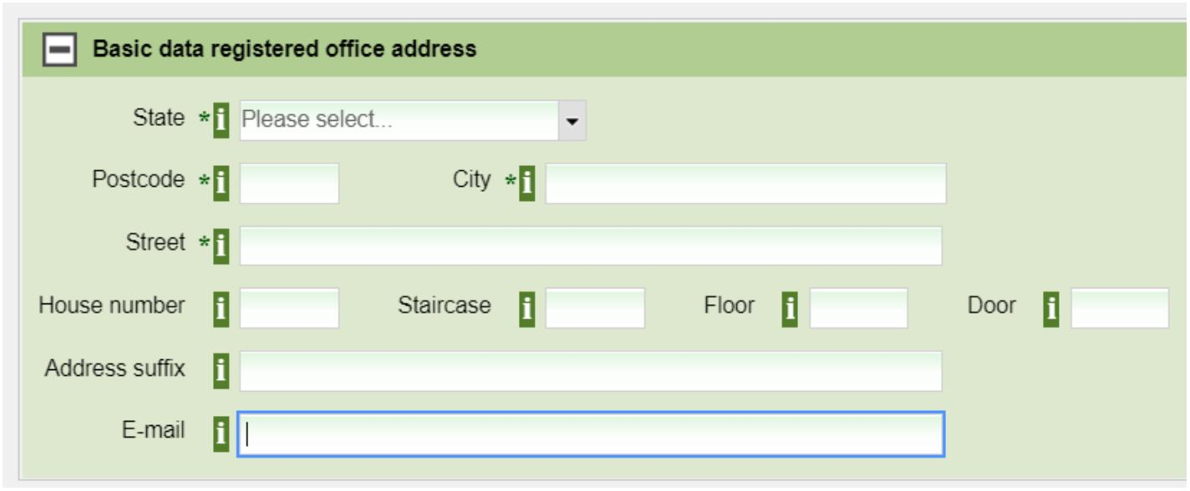

Continue by clicking the “continue”-button
On the next page, a short name for the company is required here:
A contact person is required here:
Please give your Non-Austrian registration number and a brief description thereof. (Note:
before giving the non-Austrian registration number, the contact person must be
specified):
Registration Guide for non-Austrian companies that carry out waste transports in Austria
Page 3 of 5
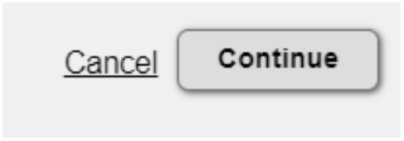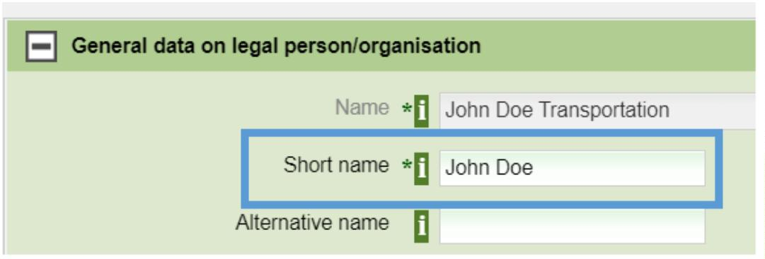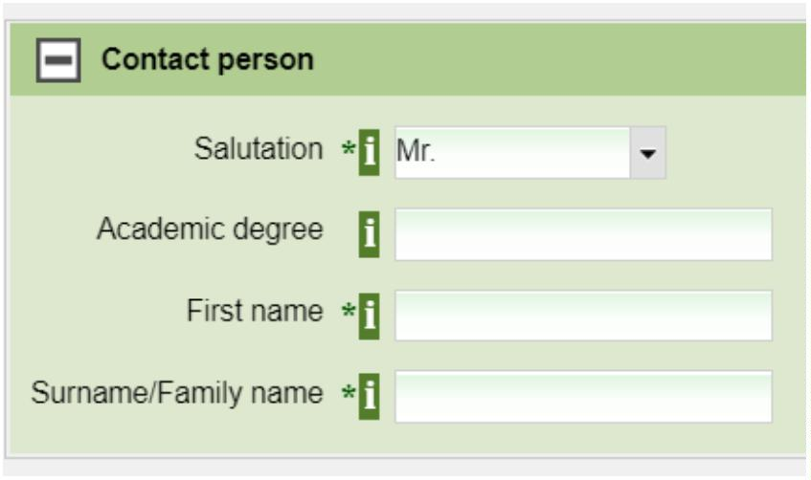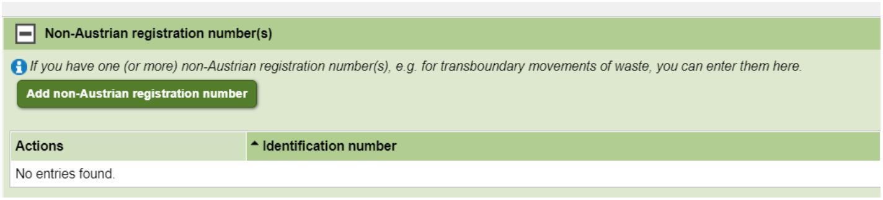

Non-Austrian registration number (example) - Please provide a brief description:
Continue by clicking the “continue”-button.
On this page, please select the entry “Waste transporter” and click “continue” to go to the
next page:
Please accept the general terms and conditions:
Registration Guide for non-Austrian companies that carry out waste transports in Austria
Page 4 of 5
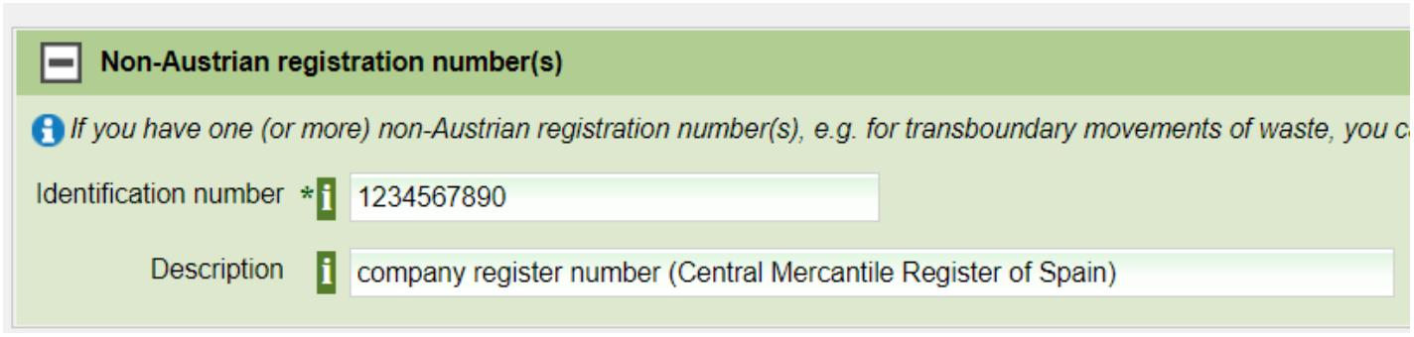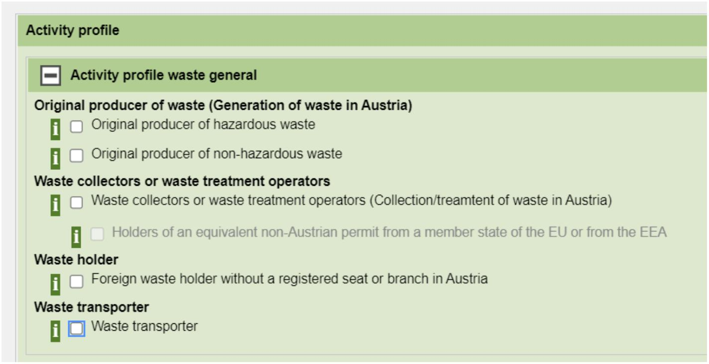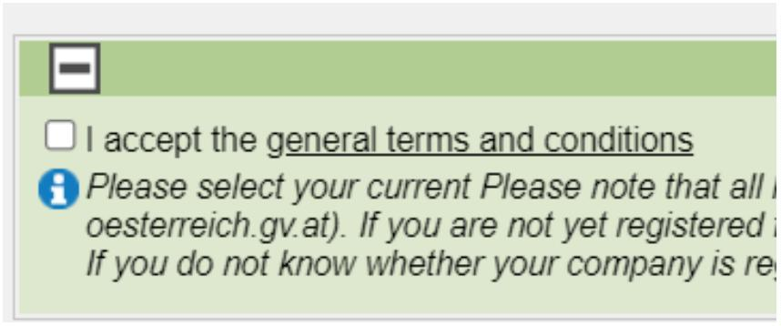

To submit your registration form, please click the “Send”-button:
Important note: After successfully submitting the registration form, you will
receive access data within a few days. In order for the registration to be
considered properly completed, it is essential that you log in to the register at
least once with those access data. Additionally, please make sure to change your
password.
Legal notice
Media owner, publisher, editor:
Federal Ministry of Agriculture and Forestry, Climate and Environmental Protection, Regions and Water Management,
Last update: 17. April 2025
Email: v2@bmk.gv.at
Registration Guide for non-Austrian companies that carry out waste transports in Austria
Page 5 of 5
